Tasks To Be Performed:

1. Create a pipeline in Jenkins

2. Once push is made to “develop” a branch in Git, trigger job “test”. This will copy Git files to test node

3. If test job is successful, then prod job should be triggered

4. Prod jobs should copy files to prod node

Procedure: -

We will use the pevious assigment where we have 2 nodes named test and prod and we have the git repo with the branch master and test. We have two files in the master branch (masterfile and newemasterfile) and 3 files in the test branch ( masterfile,testfile and test2file).

Goto the configurations of the job2 and deselect the checkbox of “GitHub hook trigger for GITScm polling” and save the configurations.

Now move to the job1 and follow the following changes.

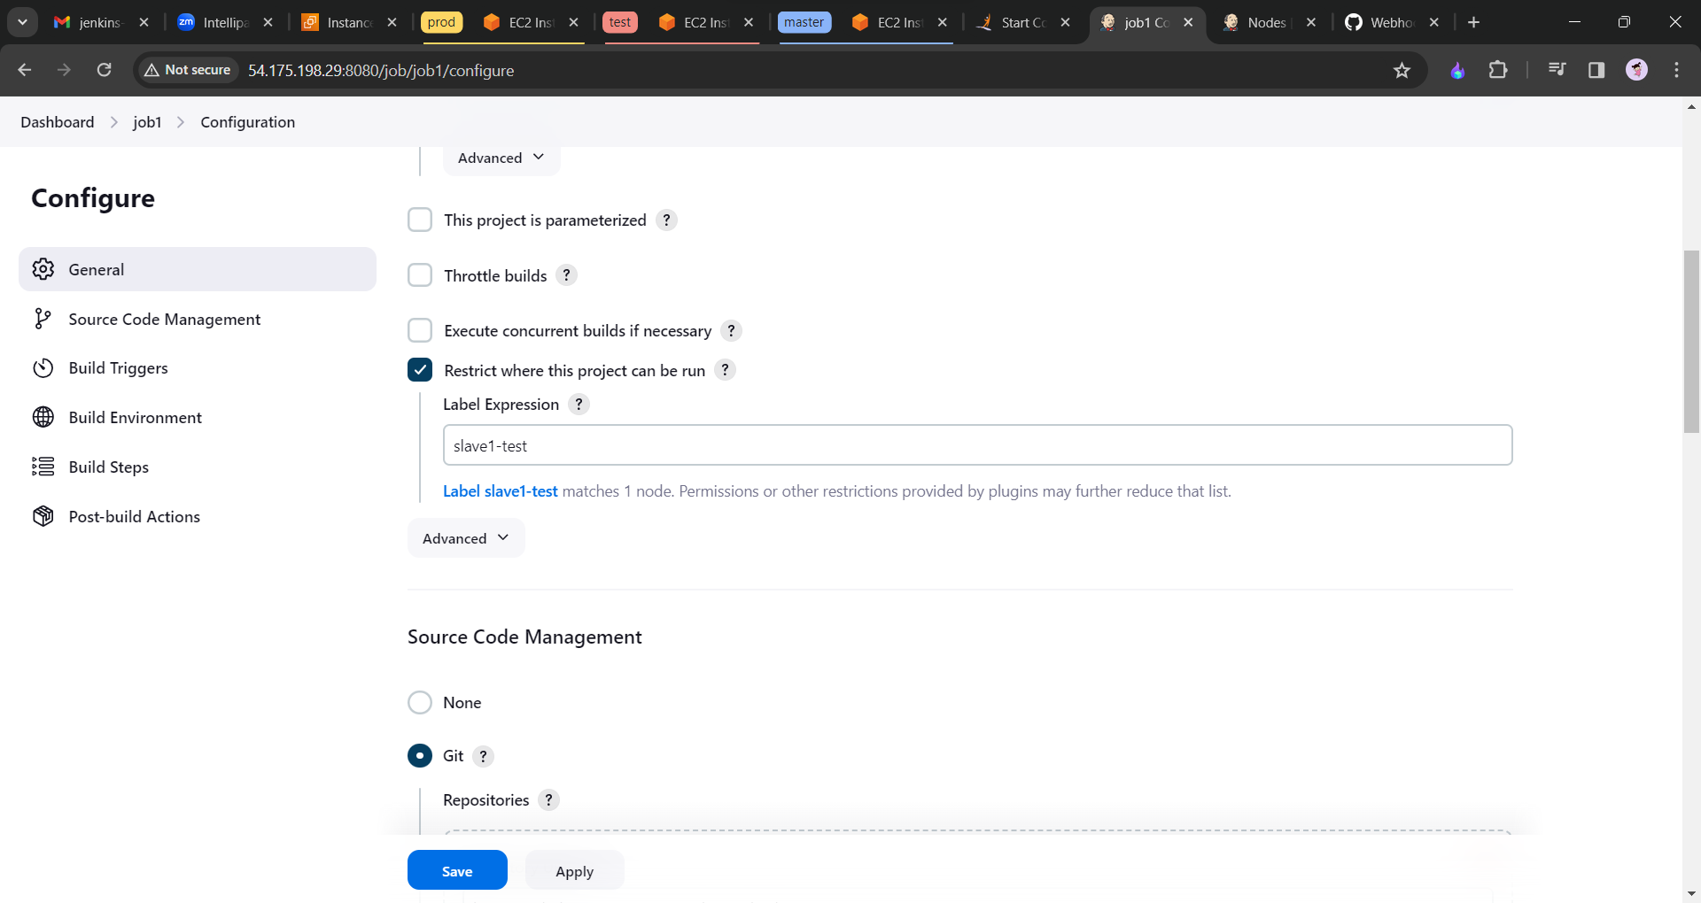

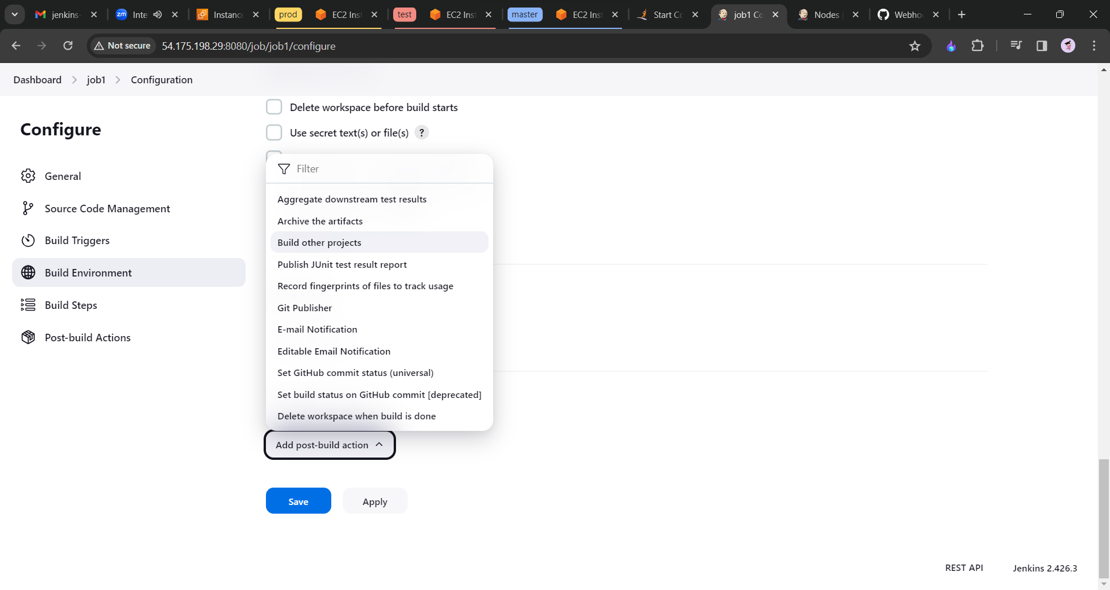

Apply and save it.

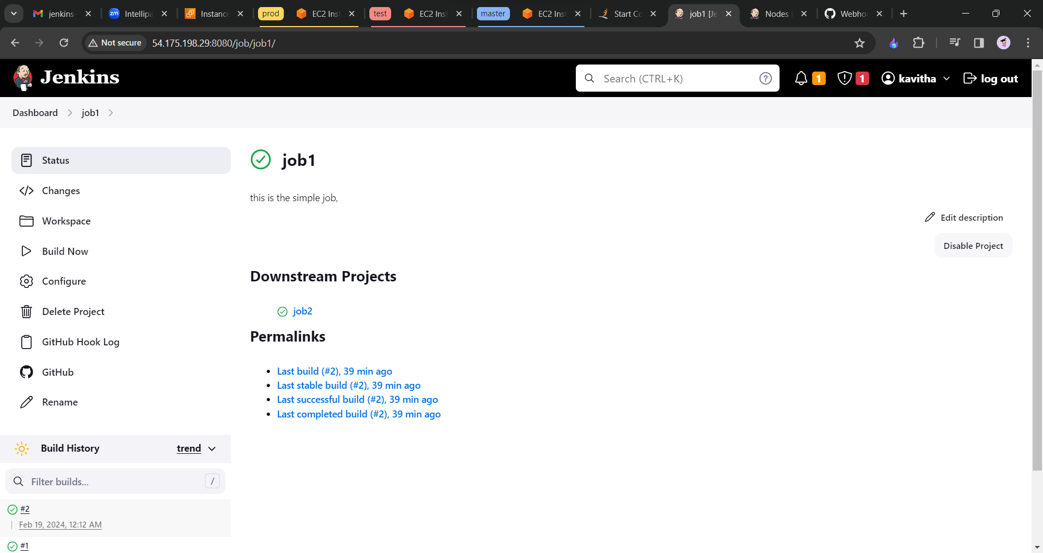

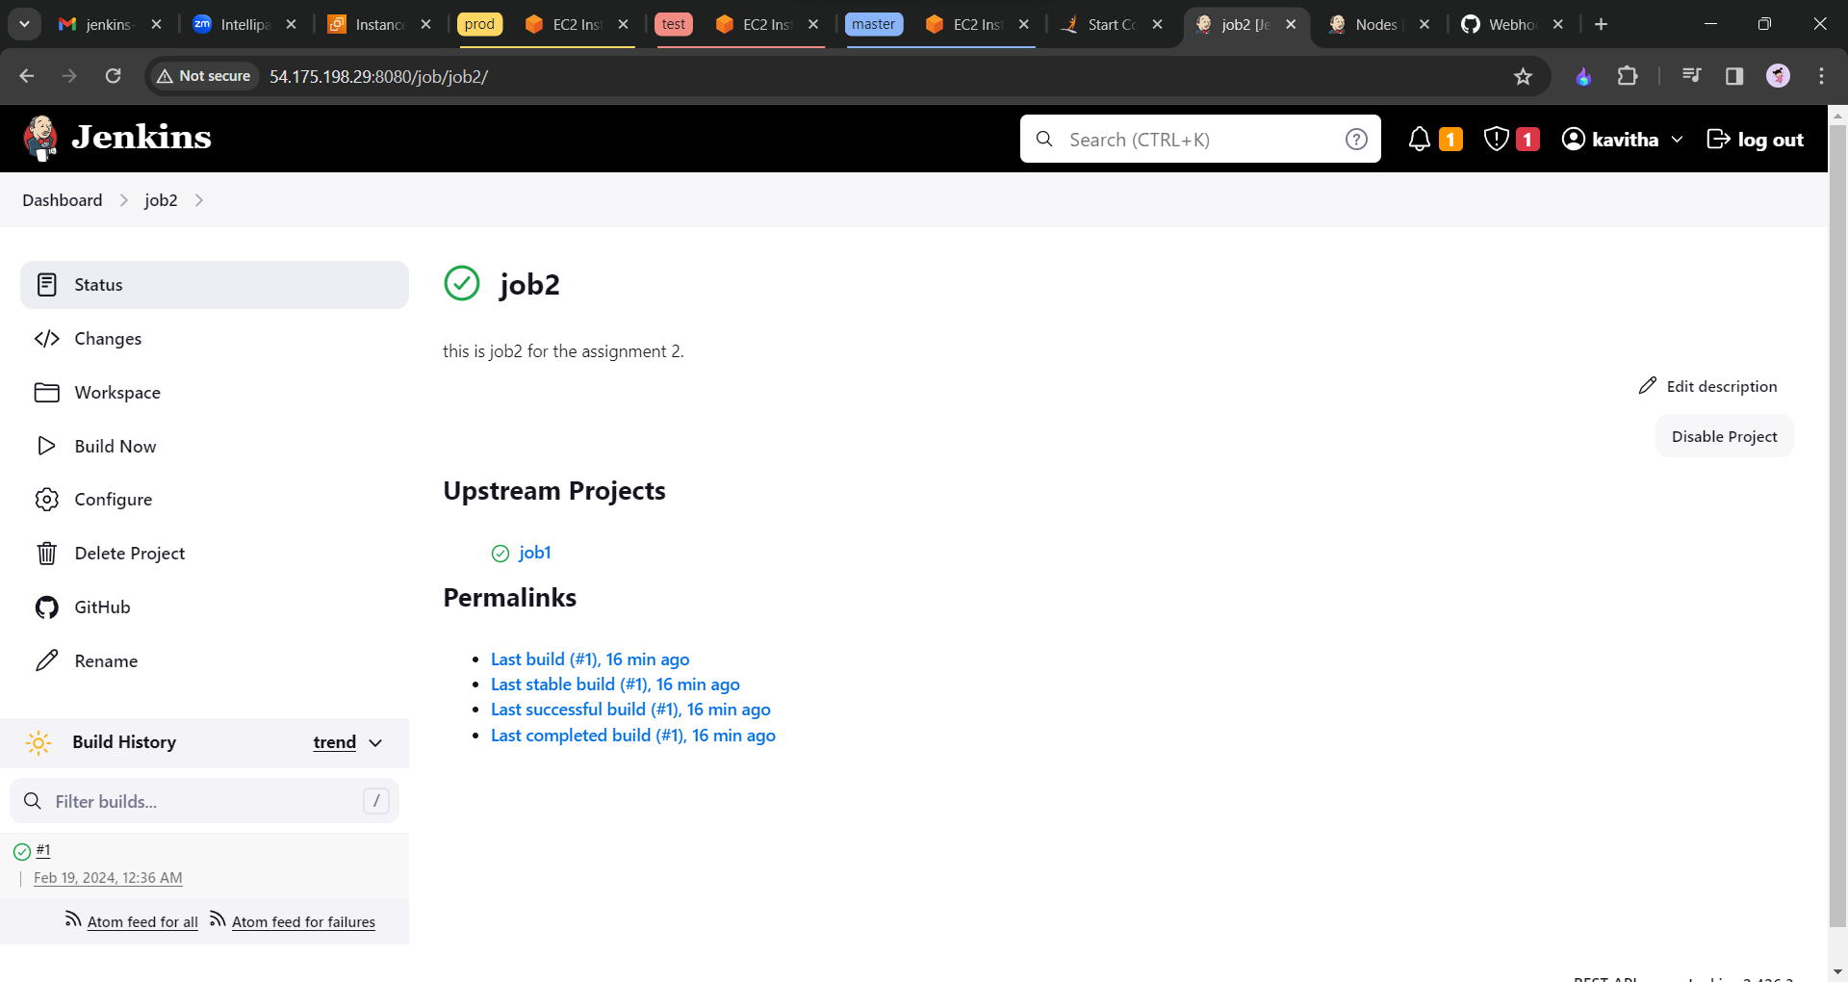

Let us make an error so that we could observe the changes in the configurations. Then click on build now.

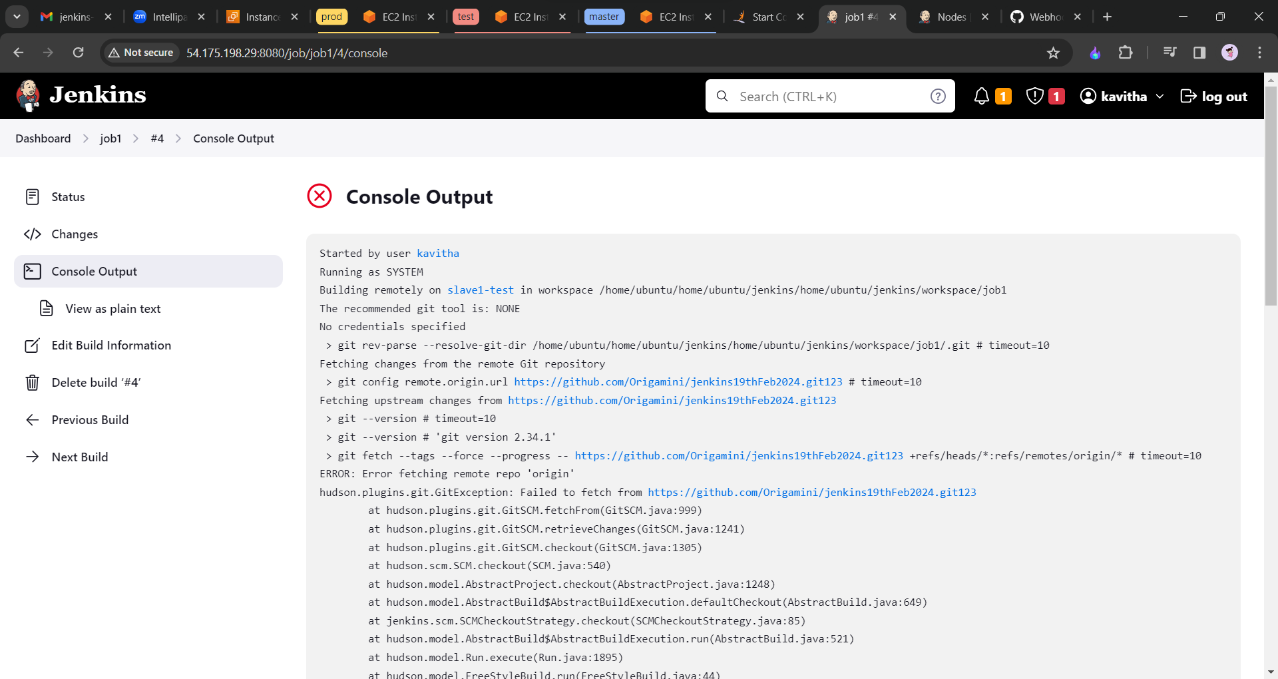

Now we will install the pluggin.

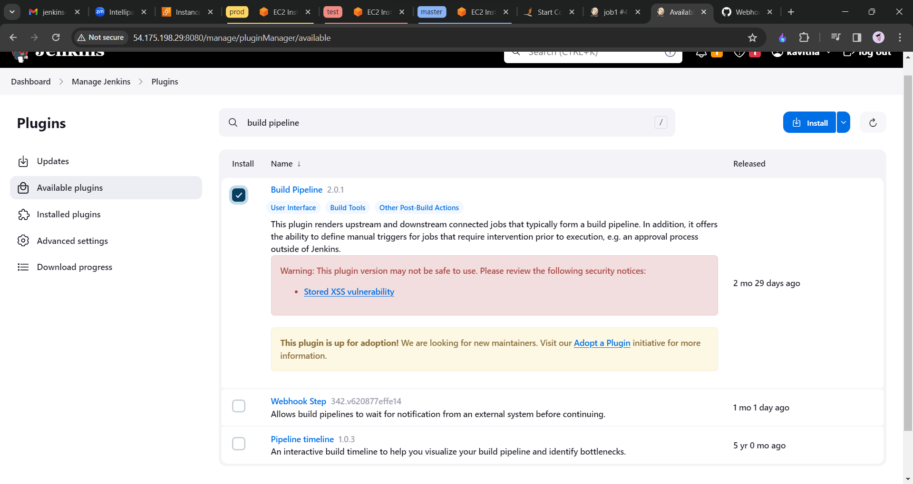

Install the pluggin.

Now go back to the dashboard and select all view and click on Add button to create the new view.

